14.10.19   
Lab Tutorial 4

H00335693 Emaduddin Shamim & H00332328 Varun Kumar Senthil

**Exercise 1**

Scenarios:

1) Logging in medicine data

2) Medicine intake reminders

3) Patient-doctor interaction

**a)** Patient-doctor interaction:

The idea here is to connect the patient with the doctor. The doctor will use the app to monitor the patient. The doctor will be able to view the medicine intake history and also the patient’s biometrics (depending on the patient’s diagnosis). This will allow the doctor to assess the patient regardless of the distance between them.

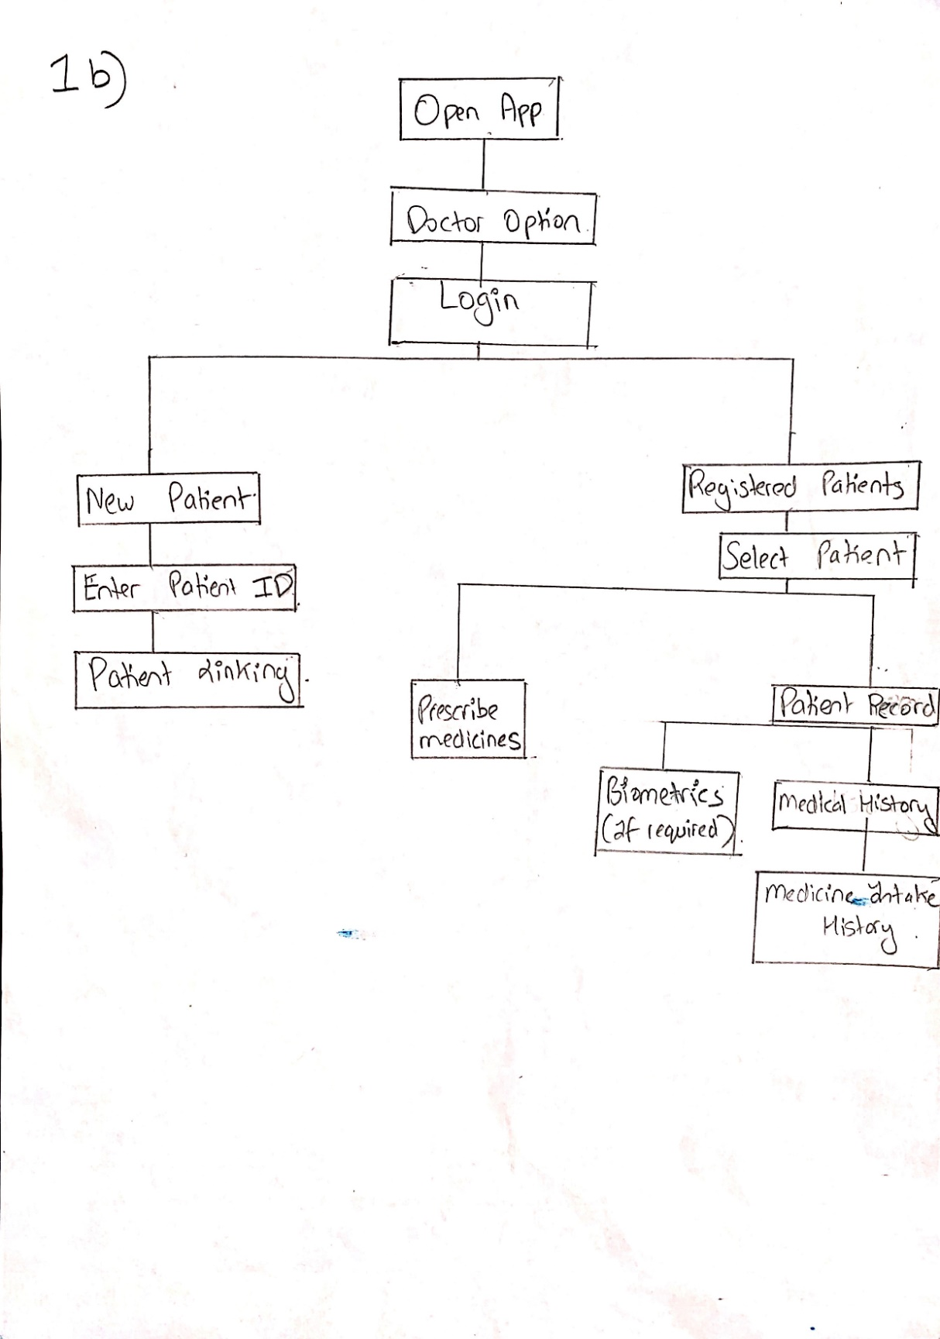**b)**

**c) Wireframe description:**

The doctor opens the app and logs in to his account. He/she will be able to choose from two options: **New patients and Registered Patients.**

Under “New Patients”, the doctor will enter a new patient’s id with whom he/she wishes to connect/monitor. After this, he/she will be linked with the patient upon confirmation from the patient.

Under “Registered Patients”, there will be a list of all the connected patients. After selecting a patient name, he/she will again have two options: **Patient Record and Prescribe Medicines.**

1. **Patient Record:** The doctor will be able to view the patient’s medical history as well as the biometrics (depending on the patient’s diagnosis). Under medical history, the patient’s medicine intake can be monitored.
2. 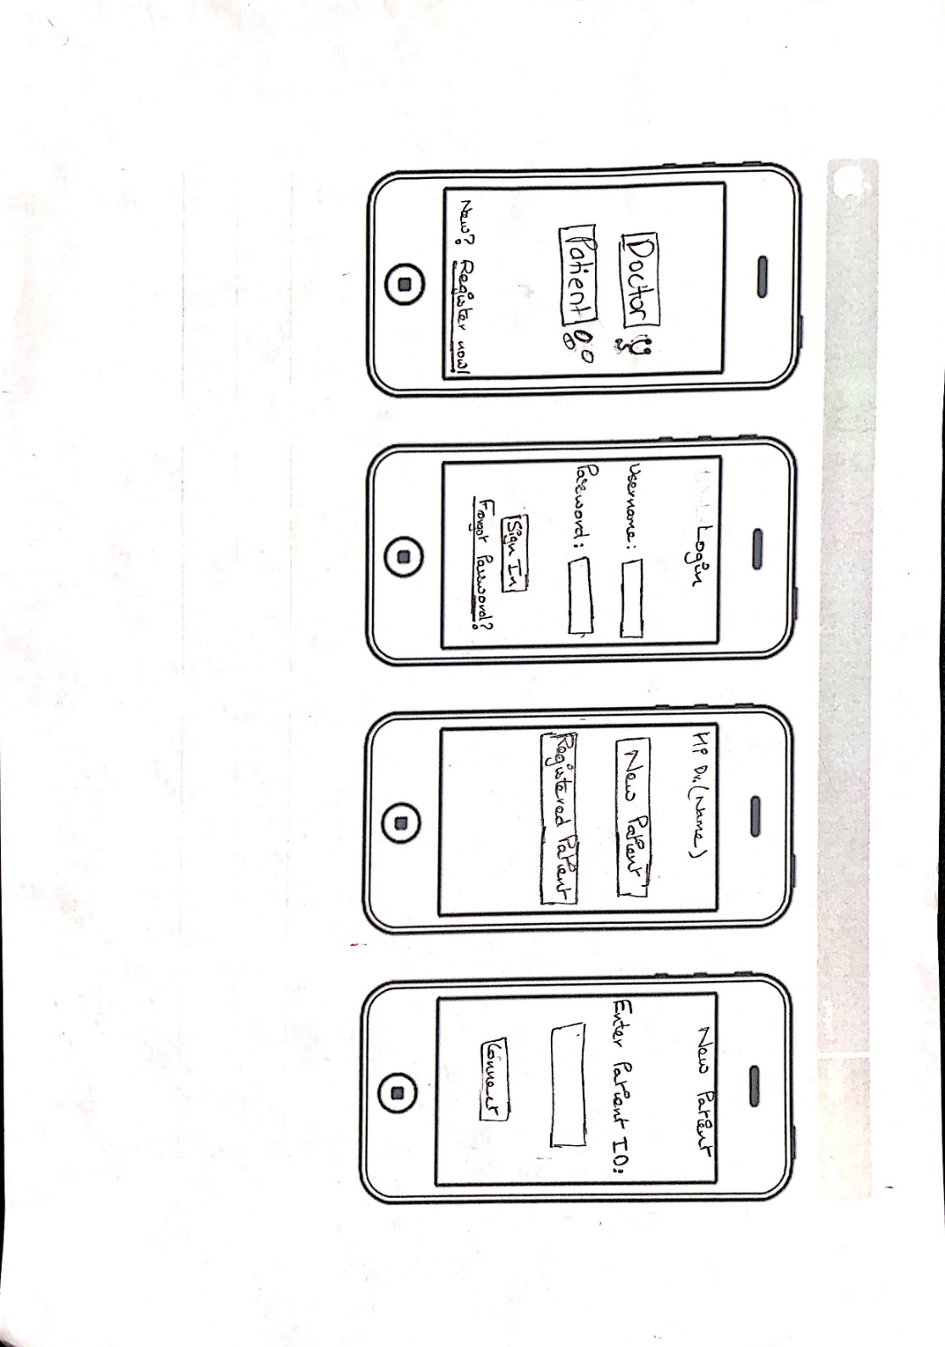**Prescribe Medicines:** The doctor will use this option to prescribe new medicines along with any extra instructions or information.

**d)**

**Adding a new patient**

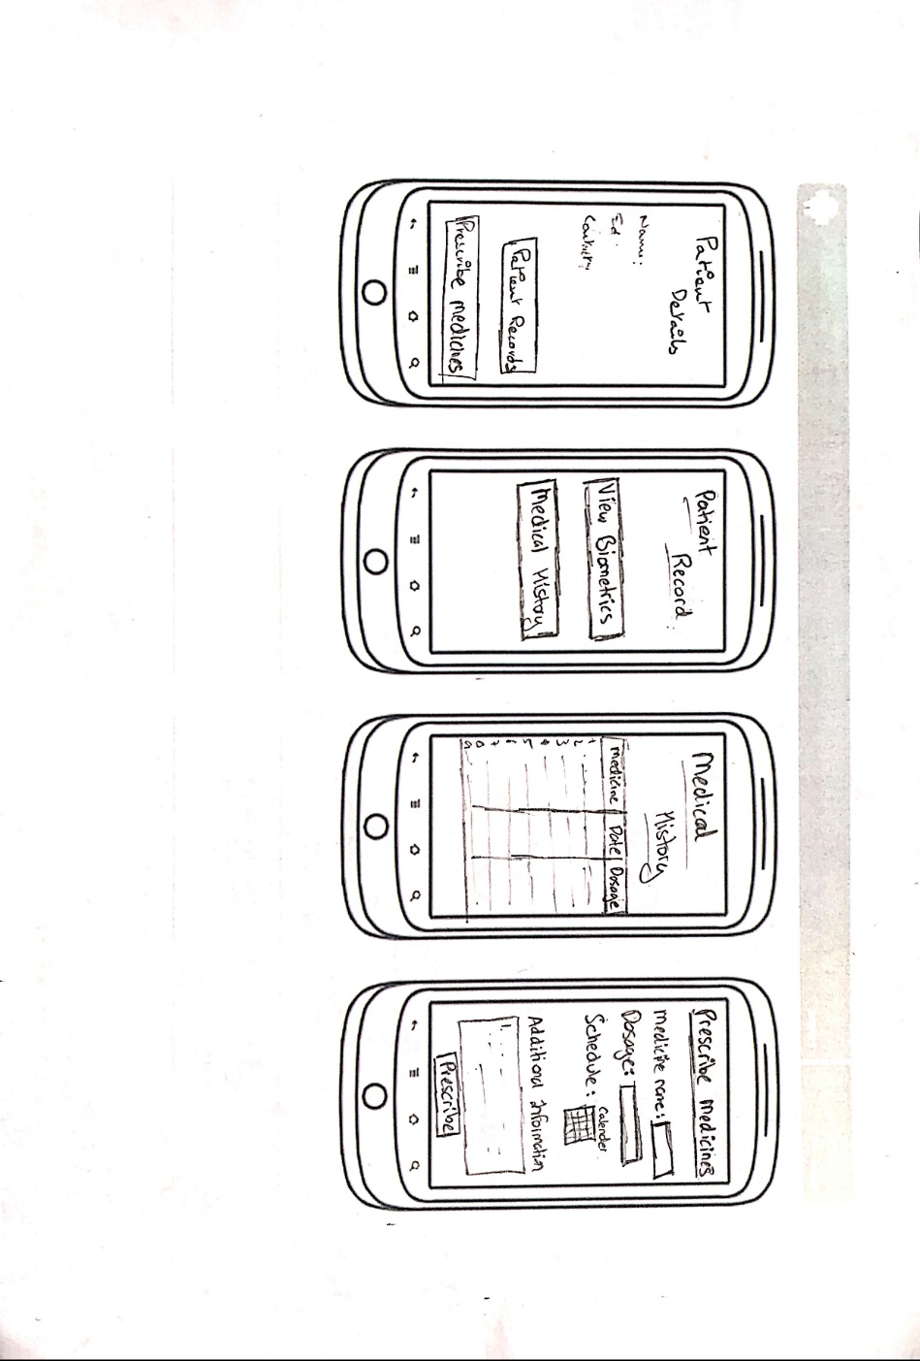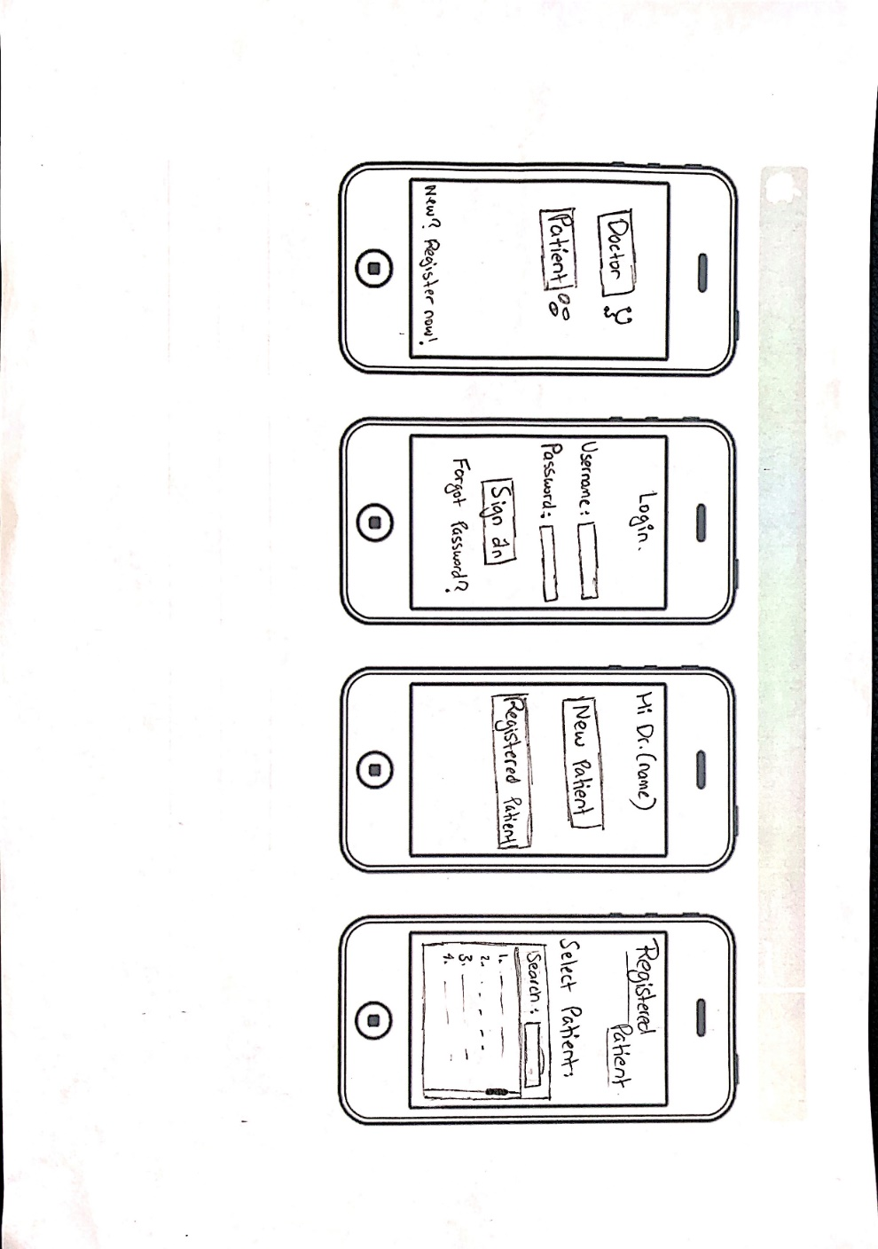**For a registered patient**